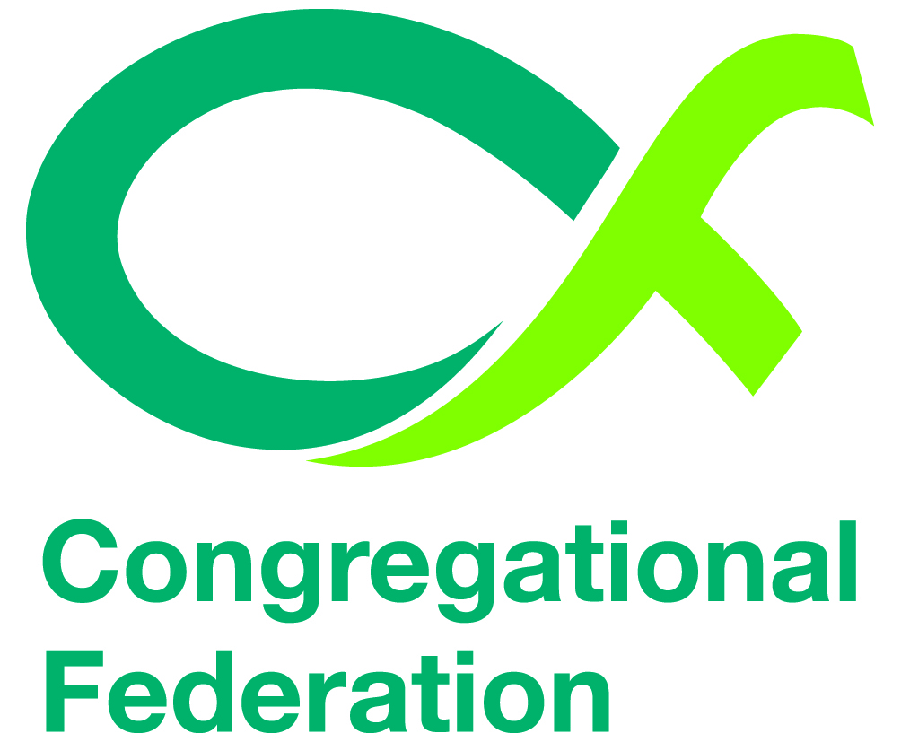
Photography Policy

CHURCH NAME Congregational Church

Adopts the following photography policy.

- We use a parental permission form to obtain consent for a child to be photographed or videoed.

- We will ask the child’s permission to use their image.

- We will avoid using children’s names (first name or surname) in photograph captions.
If the child is named, we will avoid using his or her photograph.
If the photograph is used, we will avoid naming the child.

- We will only use images of children in suitable dress to reduce the risk of inappropriate use. Some activities – swimming, drama, gymnastics and athletics for example – present a much greater risk of potential misuse.

- We closely monitor how we use of images of children on our church’s website. Images accompanied by personal information, e.g. this is X who likes to collect stamps – could be used by an individual to learn more about a child prior to grooming them for abuse.

- We ask for written expectations of professional photographers or the press who are invited to a church event, making clear the church’s expectations of them in relation to child protection.

- Do not allow photographers unsupervised access to children.

- Do not approve photography sessions outside the event or at a child’s home.

- Do not post images on any social networking websites.

- Written permission to be obtained from the parent/guardian of the child for each event or annually if the group/activity meets regularly.

- Hold permission forms/documents securely and dispose of them safely. Do not use the forms for any other purposes and do not pass on information to any other person or organisation.

Agreed at Church meeting held on:
Signed:
Position in Church:
Date:

Consent form
Confidential

We recognise the need to ensure the welfare and safety of all children.

In accordance with our child protection policy we will not permit photographs, video or other images of children and young people to be taken without the consent of the parents / carers and children.

This group follows the policy agreed by the Church meeting for the use of photographs/videoing.
A copy of which is included overleaf

We will take all steps to ensure these images are used solely for the purposes they are intended.

If you become aware that these images are being used inappropriately you should inform an officer of the Church immediately

I/we …………………….………………………………………………………………………(parent/carer)

consent to …………………………………………………………………………(church or group name)

Photographing or Videoing

(Name of child)………………………………………………………………... ……………………………..

At the following event/activity (details of event/activity)

………………………………………………………..…………………………………………………………

……………………………………………………….…………………………………………………………

………………………………………………………….………………………………………………………

Signature ………………………………………………………………………………………………………

(Relationship to child)………………………………………………………………………………………...

Signature ………………………………………………………………………………………………………

(Relationship to child)………………………………………………………………………………………...

Date: …………………………………………………………………………………………………………...

PLEASE RETURN TO

………………………………………………………………………………………………….

