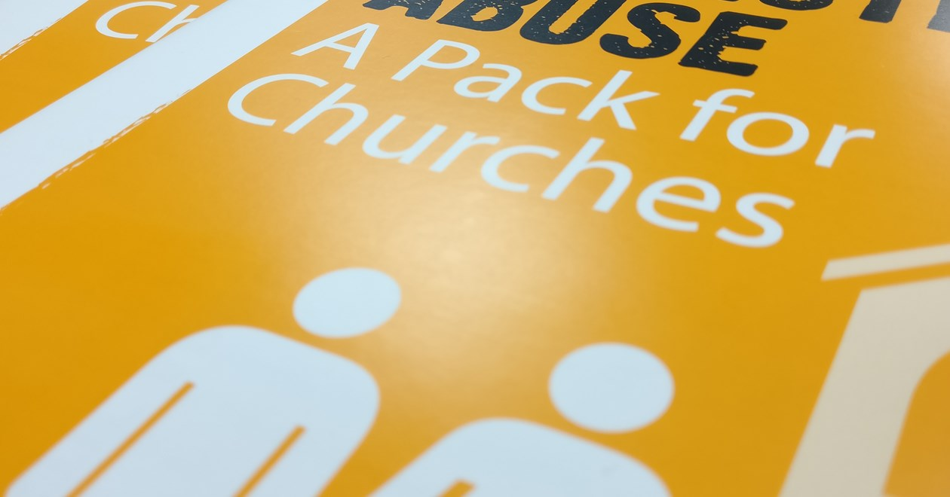

In April Restored released their report called In Churches Too: Church Responses to Domestic Abuse to help understand how domestic abuse affects churchgoers in the UK. Restored work to transform relationships and end violence against women. Thirtyone:Eight has been working in partnership with them for a number of years to help raise awareness about this issue and offer training to churches in tackling this form of abuse.

The research provides evidence on domestic abuse at local-level, focusing on the county of Cumbria in north-west England. One of the most alarming findings was the number of respondents who are ‘experiencing systematic abuse of different kinds on at least a weekly basis.’ Emotional abuse was the most commonly experienced form of abuse and while many had experienced this once or twice in their lives, for more than one in ten this was occurring at least weekly.
The UN defines domestic abuse as: ‘Any act of gender-based violence that results in, or is likely to result in, physical, sexual or psychological harm or suffering to women, including threats of such acts, coercion or arbitrary deprivation of liberty, whether occurring in public or in private life.’ The Care Act broadened this to violence between any family members, not just intimate partners.

So what does this mean for the Church?

The Restored report states that: ‘Those who had sought help for domestic abuse were more likely to have done so outside the church.’ Reasons for victims not seeking help at church included: they were not involved in a church at the time, feeling too embarrassed or ashamed, feeling it was their duty to make the relationship work, and not knowing or trusting anyone at church well enough.

It is hard to come to terms with the reality that domestic abuse can happen in our churches by our fellow Christians. Yet abuse is perpetrated by Christians, and women in our congregations can suffer in silence due to the shame and stigma surrounding abuse. Christian homes are not immune to domestic abuse. There will be both victims and perpetrators within places of worship. The responsibility to offer help and be a voice for the prevention of domestic violence is fundamental to core Christian values: those of justice, equality, respect and care for one another. To ensure the physical safety and spiritual well-being of those coming through their doors, Christians must be prepared to respond appropriately with knowledge and compassion in an effective and safe way.

Here are some things to consider when supporting a victim of domestic abuse:

- Find a safe place and time for the person to talk. Listen and take what they say seriously. Their description is only the tip of the iceberg.
- Have someone else present – if this is acceptable to the victim.
- Give priority to their immediate safety.
- Empower them to make their own decisions.
- Support and respect their choices. Even if they choose initially to return to the abuser, it is their choice. However, if there are children involved their safety must come first.
- Give them information about relevant support agencies and, if appropriate, offer to contact the agency on their behalf and do so in their presence or offer a safe and private place from which they can contact the relevant agency. Use the expertise of those properly trained.
- Reassure them that this is not their fault and that they don’t deserve this treatment.
- Love and support them and be patient.
- Protect their confidentiality.
- Understand that couple counselling, family mediation, marriage courses and healthy relationship courses will not help domestic abuse situations.

Information taken from: Domestic Abuse and the Church - Matt Cooper, Thirtyone:eight
Domestic Abuse Webinar by Thirtyone:Eight

PRICE PER PERSON
£49.99
5 DELEGATES +
£44.99
TO BOOK CALL:
03 03 003 11 11 (Option 3)

https://thirtyoneeight.org/training/specialist-courses/domestic-abuse-webinar/

Course details:
This interactive webinar is delivered over two consecutive sessions, each lasting 2.5 hours.
Our professional and experienced trainer will use a range of methods to engage delegates from presentation slides to audiovisual clips and small group exercises. The session is varied and delivered at a steady pace for those who are familiar with safeguarding terminology.

Please note: You will need to attend both sessions in order to complete the course.

Course aims:
This course will explore and raise awareness of the prevalence and impact of Domestic Abuse encouraging all who attend to understand that the church is not immune from these issues and that they can take action to address this form of abuse. This course is for anyone who is passionate about preventing Domestic Abuse and helping those who are in such situations to access the right support.

This course has four modules. Modules one and two will be covered in the first session, modules three and four will be covered in the second sessions. You will need to attend both sessions in order to complete the course.

Session 1
- What is Domestic Abuse and who is most affected?
To develop a clear understanding of domestic abuse and who is affected by it; exploring power dynamics, myths, perceptions and current research and statistics.

- Domestic Abuse and the Impact on Children.
To understand domestic abuse within the context of its impact upon children; exploring signs and indicators of domestic abuse using case studies and scenarios.

- Theological reflections and the role of the Church.
To have been given the opportunity to explore and reflect upon relevant theology and to identify ways that the church might influence perceptions and be a catalyst for change.

- Strategies for Support and creating safer cultures.
To gain insight into strategies and support available for those facing domestic abuse and to explore what safer cultures might look; with opportunities to develop your own action plan.

Course dates
- Monday 16th November - Tuesday 17th November 10:00 - 12:30
- Saturday 28th November - 9:30 - 12:00 & 14:00 - 16:30
- Saturday 30th January - 9:30 - 12:00 & 14:00 - 16:30
- Tuesday 23rd - Wednesday 24th March 10:00 - 12:30
- Monday 13th - 14th Tuesday September 10:00 - 12:30

